Shabbos Stories for
Parshas shoftim 5780
Volume 11, Issue 50 2 Elul/August 22, 2020
Printed L’illuy nishmas Nechama bas R’ Noach, a”h

For a free subscription, please forward your request to keren18@juno.com
Past stories can be found on the website ShabbosStories.com

From Catholic Italian to Jewish Rabbi: David Martinetti Shares His Story
By Sofya Sara Esther Tamarkin

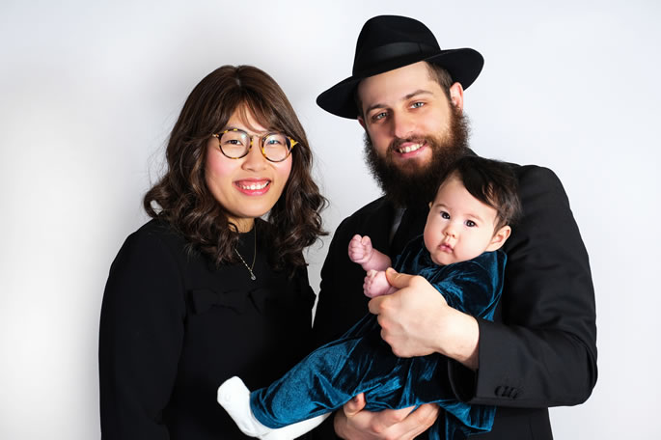
Elisheva and David with their daughter, Chana.

A few months ago, I first shared a story about my encounter with Elisheva Martinetti, at the time a 16-year-old Chinese girl who was hoping to convert to Judaism. When Elisheva heard about the article, we were virtually reunited 10
years after our original encounter, which led to an interview where we spoke openly about our respective childhoods in Communist USSR and China respectively, and the choices we made to embrace Judaism and the Torah way of life.
But the story doesn't end here. I have been blessed to discover that Elisheva’s husband, David, has an awe-inspiring journey of his own!

David Martinetti was born an only child to a typical Italian family in a small city called Cesano Boscone, an hour away from Milan. His parents were traditional Catholics, but not particularly observant in their daily lives. From a young age David questioned the authenticity of his parents’ traditions, yet the answer he received did not satisfy his curiosity.
At some point during his teenage years, David came to the understanding that the foundation of the Christian faith is Judaism, and felt it important to pursue the source and read original texts.

Attended an Annual Celebration of
Italy’s Liberation from the Nazi Regime
By the time he was 16, David still hadn’t encountered an opportunity to meet an actual Jew. On April 25, 2010, he attended the annual celebration of Italy’s liberation from the Nazi regime, where he saw representatives of the Jewish Brigade Group wearing Jewish attire. His dream of meeting a Jewish person was coming true at last!
“As I went up to speak to the group, I told them that I was interested in their organization. One of the members invited me to participate in a celebration of Israel’s Independence Day just a few weeks away.
“Although this was my first encounter with ‘real’ Jews, I had secretly already been trying to learn to read Hebrew on my own. Unfortunately, my parents were not particularly supportive of this new interest. So while I did not share my plans to attend the Israel Day parade with my parents, I let my grandmother in on the secret, and on the much anticipated day, she traveled with me to Milan to help me find my way.
“I was so excited that I arrived hours early. It was there that I saw an Orthodox Jew, a real rabbi, for the first time in my life. He had arrived early too, to set up his outreach work for the large crowd that was anticipated.
“I stood alone, observing him. The rabbi walked toward me with a smile, extended his hand warmly, and offered me my first Jewish greeting: ‘Shalom.’ I froze, completely overwhelmed.
“As the day unfolded, I observed this warm and friendly rabbi putting “black boxes” (tefillin) on participants, smiling and answering questions. I felt instantly connected to him. After all, he was the first rabbi who shook my hand and greeted me in the holy tongue. Unfortunately, I was too shy to speak to him or ask questions.”
By that summer, David had made the life-changing decision to join the Jewish people. Of course, at the time, he had no idea what conversion to Judaism entailed or just how complex his journey was going to be. Despite the challenges that lay ahead, his determination was undeterred, and just like his future wife, Elisheva, he was committed to sacrifice whatever it took to become a part of the Jewish people.

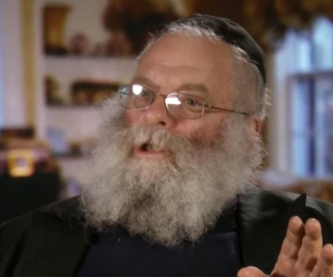
Rabbi Shmuel Rodal

“It took a lot of courage before I finally dialed the number of one of the organizers from the Israeli parade,” David recalls. I asked to be connected to a teacher who could help me learn about Jewish traditions. Amazingly, when I finally met my potential rabbi, I was greeted by that same friendly face and unforgettable smile of the rabbi who shook my hand months ago—a clear sign that I was on the right track.
“It was the beginning of my lifelong connection with Rabbi Shmuel Rodal. We started learning about the Seven Laws of Noah. Although 16 people attended the second class of the series, I was the only student present for the first, which gave me an opportunity to ask questions, bond with the rabbi, and confide in him my desire to convert.”
The weekly classes took place in Milan, ending late night when the trains were no longer running.
David’s parents picked him up after the first class but made it clear that they were unwilling to do it again. After the second class, he was visibly worried that he had no way of returning home. Just then, his fellow classmate shared that he lived a few minutes away from David’s house and would be happy to give him a ride home each week. Once again, David saw this as a sign that he was on the right path and was being guided by his Creator.

His Commitment to His Jewish Education Intensified
As time went on, David’s commitment to his Jewish education intensified. He appealed to Rabbi Rodal to include lessons on important Jewish ideas, in addition to the Seven Noahide Laws. Recognizing how seriously the young man took his studies, Rabbi Rodal agreed to teach him twice a week.
By this time, David knew with certainty that he belonged with the Jewish people.
“When I turned 18, I became legally independent and decided to move to Israel. My parents were shattered and went to speak to the rabbi, asking him to convince me to finish high school in Italy.
“The rabbi listened to their anguish and told me, ‘David, whatever you start in life, you need to finish. You need to complete your high school education and then move on to the next stage of your life.’ The rabbi also advised me to honor my parents and get the best grades possible.
“I listened to his advice, spending hours toiling over my homework, and graduated high school with all A’s. After my graduation in 2012, I started looking for a Jewish school—a yeshivah either in the United States or in Israel—with hopes of beginning my conversion process. I knew that I needed to start living in a Jewish environment.

An Increasingly Complicated Relationship with His Parents
“It had become increasingly complicated for me and my parents to live together. Unfortunately, my plan to attend yeshivah did not come to fruition since no Jewish school was willing to take me in. Once again, Rabbi Shmuel Rodal acted as my guardian angel and offered to create a custom curriculum just for me. For two full years, we studied together every day for four hours.
“The first year, I continued to live at home, hiding everything Jewish in order not to upset my already aggravated parents. At the end of the year, I moved in with my grandmother where I could be more open about my observance.
“During the summers, Rabbi Rodal was away in another city so I had to take a break from our learning. My usual daily schedule included a two-hour commute, our four-hour learning session, as well as extra time with the rabbi’s family. Since I no longer had anywhere to go, I moved into a vacant family vacation home, where I spent my days watching countless videos of the Lubavitcher Rebbe’s talks. There, in isolation, I worked to improve my Hebrew reading skills, spending hours in prayer and study.”
As I listened to David share his story, I thought back to the way I concluded my first article about Elisheva. At the time I did not know what had become of her, so I simply wrote what I imagined: “In my dream, she is holding hands with her skirt-wearing daughters, while her kippah-wearing husband is talking to her in a soft, kind voice.”

The Kippah-Wearing Husband
Incredibly, David is that kippah-wearing husband, and they do have a little girl. Sometimes, reality is even more magnificent than dreams! Yet I could have never imagined that while Elisheva was finding her way to the Jewish people, David was seeking the same truth in another part of the world.
While David was alone in his journey, fortunately Elisheva had support of her mother.
When I asked David where he drew his courage, despite his loneliness and the resentment from his family, he explained:
“In one of the many arguments with my mother, she tried to reason with me, saying that even if I was to convert to Judaism, I would never truly belong because no ‘real’ Jew would ever marry me. She was certain that I would be completely alone in the world.
“She was worried that I would have no friends, no community, and no support. She was genuinely concerned. I was surprised by my own reply when I asked her, ‘What is the difference between gold and aluminum?’ She was confused by my question. I explained that while both metals seem similar, gold is infinitely more valuable and rare. I understood that I could have a lonely, unfamiliar life, yet to me the value of the ‘golden’ truth was infinitely greater than all the noise of the mundane ‘aluminum’ world.”

Found His Authentic Truth and
Nothing Could Stand in His Way
David found his authentic truth, and nothing could stand in his way.
“At the end of my second year of intense studies, Rabbi Rodal smiled and announced that by Rosh Hashanah I would be counted as a 10th person in the minyan. I was converted by a beit din, a Jewish court of law, in Brussels, on the 24th day of the Jewish month of Elul. I didn’t know it at the time, but the day already had significance as it is Elisheva’s birthday!
“Two months after my conversion, I went to study at a yeshivah in Safed, Israel. Rabbi Rodal arranged and paid for my studies. No words can express the gratitude that I feel. His time, generosity, thoughtfulness and financial support can never be repaid. I simply want to emulate his kindness by the way that I live my life. This is the only way I can honor the rabbi that changed my life.”
Two years prior to David’s arrival in Israel, his future wife, Elisheva, was studying a few blocks away in this same city, growing in her own journey. Three years later, their destinies would merge.
After studying in Israel for two years, David went on to learn in a yeshivah in the Crown Heights neighborhood of Brooklyn, N.Y. Once again, he was embraced by the kindness of the Jewish people. He met the Blizinsky family who “adopted” him as their own. He ate every meal at their house, where he met their niece and her friend. The young women knew Elisheva, who was teaching in London at the time, and thought of introducing them.
When I spoke to David about meeting his wife, he concluded that the story was nothing short of a miracle.

Afraid of Not Being Married
By His 24th Birthday
“When I began to date, my parents were not the only worried ones. Many people expressed their concern for my future. After all, I had a complex identity and an unusual past. At some point, I decided for myself that if I was not married or engaged by my 24th birthday, I would never find the right girl. While this was a silly notion, the thought haunted me. In the end, Elisheva and I celebrated our engagement on the night of my 24th birthday.”
Elisheva and David were married in London in October 2018; their wedding was attended by friends and rabbis from China, Italy, Israel, Australia and the United States.
Their stories span continents and cultures, each detail clearly orchestrated by Divine Providence.
Today, David’s parents are proud of the life he has built with Elisheva. They love to visit and play with their beautiful granddaughter. David’s grandmother has also visited. David is a rabbi and continues to spend his days learning Torah. His wife is his greatest supporter.
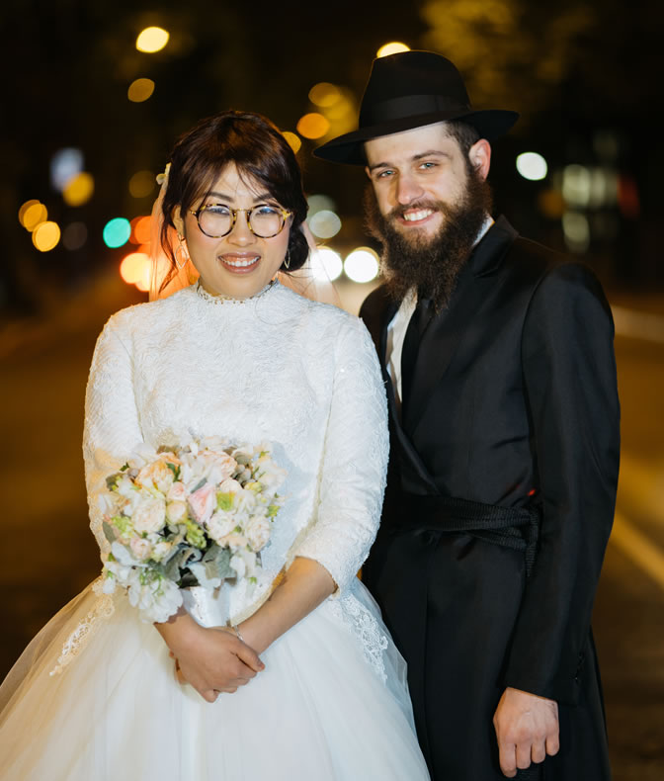

Before we concluded the interview, I asked both David and Elisheva about their future dreams. I was not surprised by the answer of this power couple.

Hope to Become Chabad-Lubavitch Emissaries (Shluchim)
“Our dream is to emulate all the kindness we received along our journeys. We hope to become Chabad-Lubavitch emissaries, shluchim, and find the place in the world where we are most needed.”
I wiped away tears as I looked through the screen of my Zoom meeting with this Chinese-born young woman and Catholic Italian-born young man.
Throughout their journey, David and Elisheva experienced Divine guidance and tremendous kindness, empathy and dedication from the Jewish people. The way these seekers of truth were treated, respected, and cared for offers us a glimpse to the powerful, eternal Light of the Jewish nation.
Their journey is a clear reminder that when a person wants to
find a path back to the Creator, no obstacles will stand in the way. As David pointed out: “A life where G-d’s ways are revealed is a life of true blessing!”

Reprinted from the Parashat Va’eschanan 5780 email of Chabad.Org Magazine.

The Man Who Felt
Something Missing
Rabbi Yosef Farhi

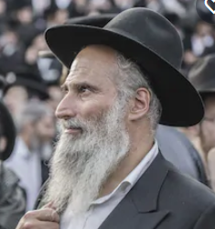
Stock photo – not of the subject of the story

There is an unassuming man that prays on the other end of my bench in shul. He is a quiet fellow, but he prays with fire. He must be about sixty years old and looks somewhat of a loner. He never comes with kids or grandchildren to shul. I have never said a word to him. Not that I am not friendly or social. It is just that this fellow prays with such fervor, by the time we are all finished and ready to leave, he is still deeply immersed in his talking to G-d.
Just recently, my wife showed me something that shook me to the core. There was a front page article in the Mishpacha magazine (Hebrew version) of a sixty-year-old living in my neighborhood in Jerusalem who just had his first child after many years.
I could not believe my eyes when I saw the picture of my bench-mate from shul, smiling and holding a new born baby in the hospital. I thought he was just “praying nicely”. Now, I realized how much of his heart he put into beseeching G-d in his prayers. How much heart he put now into thanking G-d in his prayers.

The Spirituality of the
People of Jerusalem
This is one of the things I love about living in Jerusalem. The spirituality of the people, the closeness to G-d here is just so unassuming. A regular-looking Avreich can have vast knowledge of Shas at his fingertips. At the still of midnight, in the Three Weeks, I hear from my bedroom window a neighbor wailing Tikkun Hatzot (all my neighbors denied it was them). And the man on the other end of the bench in shul, who did not have kids all his life – turned over the Heavens in prayer and merited a child at a ripe old age.
“These are the people in your neighborhood, the people that you meet each day.” Whenever I contemplate moving back to America, this thought buckles me down in Bait Vegan, Jerusalem. My greatest wishes, my deepest desires are that people like these might make an effect on me and my family. I might one day pray the way a Jew is supposed to. Maybe I will know some part of Shas well. And, hopefully, I will cry for the Beit Hamikdash along with that neighbor. It is not that the whole of Jerusalem is filled with such people. It is just that they exist here. Just a reminder of what things are supposed to look like.

Analyzing the Scale of
Human Happiness
Whenever I see the sixty year old young father, a thought floods my thinking. When someone has a child after waiting so long , the happiness is no less than ecstatic. If we would make some kind of a scale of all the happiness of the world, including the greatest happiness that a person feels, it could very well be that this fellow has experienced it.
The reason for this is that when someone wants something so very much and then gets what he felt he was so sorely lacking, the happiness is in proportion to how much he wanted it. Whenever there is something lacking, like a missing part of a picture, the more its absence is felt, the greater the happiness when what is missing is filled. A couple without a child is a family missing a member. Immense happiness is felt when the picture is complete.
This is the way G-d made the emotion of happiness – it springs from the heart when the missing thing is found. Unhappiness is wanting something and not getting it . And this sort of “wanting”, deep yearning, comes when a person feels there is something significant, basically necessary and important to his life, missing. Like the feeling that things, in general, are not the way they are supposed to be.

Reprinted from the archives of Shabbat Shalom from Cyberspace edited and compiled by Rabbi David Bibi.as reprinted in the Parshat Vaethanan 5780 email.
The Rewards of a Proper Birchas Hamazon

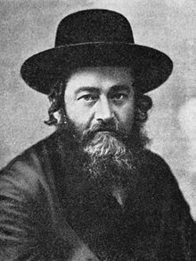
Rabbi [Yehuda] Meir Shapiro, zt”l

Reb Shimon (an elderly Yid from Yerushalayim) lived in Lublin in his youth, shortly before the Holocaust. Reb [Yehuda] Meir Shapiro, zt'l, (1887-1933) once came to his cheder to test the students. After the test, Reb Meir Shapiro said to the students, “Generally, I give gifts or sweets to the children after a test, but this time, I don’t have anything with me to give you.
“So, I will tell you about a segulah, and that will be my gift to you. If you follow this segulah, you will always be successful, and you will lead tranquil lives."
Reb Meir Shapiro told them to be cautious with birchas hamazon (blessing after a meal with bread). He said to them that the Ba'ch says that birchas hamazon is a segulah for protection, and he told them that the Chinuch says birchas hamazon is mesugal for parnassah b'kavod (dignified livelihood). He also said to them that the Be'er Heitav writes, "Those who are cautious will always say birchas hamazon from a siddur, and not by heart." Reb Meir Shapiro zt'l quoted these sources and concluded, "This is my present to you."
Reb Shimon drank in the segulah – which was Reb Meir Shapiro’s gift to them – and he decided right then and there that he would always be careful with birchas hamazon. In cheder, his friends would bench quickly and go out to play, while he lingered, because it was important to him to bench properly. A few years later, the Nazis invaded Poland. Soon, Reb Shimon found himself standing in line for a 'selektzia.' Whoever was short was being sent to the left for execution, and Reb Shimon was short! He prayed that he be saved from 'wrath and in) שצף קצף חרון אף) ‘punishment the merit of birchas hamazon.

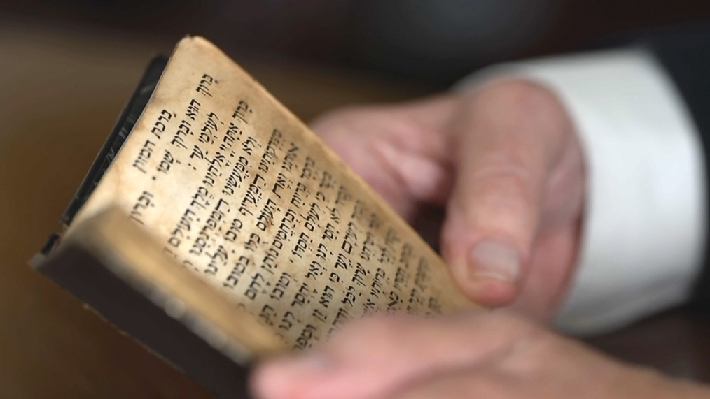

When it was his turn, he stood on his toes to appear higher. The Nazi signaled to the right. Soon, Reb Shimon found himself standing in line once again. This time, each person had to tell the Nazi what he could do for parnassah. Reb Shimon didn’t know what to say. He was only a teenager, taken away from yeshiva to this cursed place. As he waited in line, he prayed, "In the merit of birchas hamazon, which is mesugal for parnassah, Hashem, please support me…"
Then, the person behind him tapped him on the shoulder, "Say you’re a cook and that I'm your helper." He said this, and they were both sent to work in the kitchen. As the Chinuch promised, since he was careful with birchas hamazon, he had enough food.
In the camps, Reb Shimon continued to be careful with birchas hamazon. For example, if he realized that he wouldn’t have enough time to say the birchas hamazon properly, he wouldn’t eat bread at that meal.
Once, a Nazi saw Reb Shimon working in the kitchen, and he said, "What are you doing here? You look like a young child."
"I work here," Shimon explained. "I’m the cook."
The Nazi took Reb Shimon outside and showed him a stony area, just outside the kitchen. "You have two hours to finish digging a two-meter ditch, or you will be buried in it." He gave him a tiny shovel.
At that time, the Nazis were digging trenches to hide in, in case the Russians would attack them. But this time, the task was impossible. The ground was covered with heavy stones, he was given a small shovel to work with, and the chore had to be finished in two hours!
Reb Shimon raised his eyes to Heaven and said, "I say birchas hamazon with kavanah. This is mesugal to save me from 'wrath and punishment.' I was saved before. Please save me again, in this merit."
A few moments later, a jeep filled with Nazis drove by and saw this young lad trying to dig a ditch with a small shovel. To tease him, they threw tomatoes, potatoes, carrots, and other vegetables at him.
Reb Shimon thought, wryly, "I see that in the merit of birchas hamazon, I once again received the brachah for abundance. Now I need the blessings for protection from wrath and punishment, too."
Shortly afterward, a jeep with Russian POWs (prisoners of war) showed up. When they saw all the vegetables around Shimon, they stopped and asked for them. (They were hungry because the Nazis didn’t feed these prisoners, either.) With an authoritative voice, Shimon told the Russians, "When there is a pit two meters deep here, I will give you the vegetables." The Russians had the right tools for digging. They took them out of their jeep and began digging the trench. There were several Russian soldiers, and the job was completed in half an hour. The Nazi who gave Shimon two hours to dig the trench returned, and he saw that the task was completed. He said, "I always knew that G-d takes care of you. I just didn’t realize to what extent."

Reb Shimon was saved once again, in the merit of birchas hamazon. When he came to Eretz Yisrael after the war was over, he continued to enjoy many blessings. He always had parnassah (a decent livelihood), and he married off all of his children honorably. He said that it was all in the merit of birchas hamazon.

Reprinted from the Parshas Eikev 5780 email of Torah Wellsprings: Collected Thoughts from Rabbi Eli Biderman.

A Vort in the
Corona Virus Era
By Rabbi Yoseph Vigler

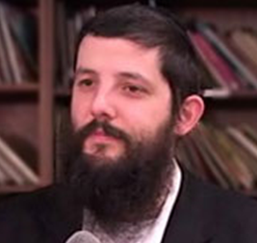
Rabbi Yoseph Vigler

Dear…
We are thrilled to invite you to the vort of our oldest child and her chosson, Menachem Mendel Hakohen Kahn, son of Rabbi Levi Yitzchak and Chana Hinda, Shluchim in Paris, France.
Wednesday, August 5th – 15th of Av
7:30pm - 10:30pm.
At Mayan Yisroel: 3315 Ave N Brooklyn NY
We are beyond thankful to the Aybishter for His incredible brochos. Over the past week, we also welcomed our new baby. Some would say we sent our oldest daughter out to make room for our youngest, we like to say we welcomed a new daughter AND a new son into our family.
Ten children feels like a wholesome Minyan. The eleventh is the extra mile, the cherry on top!
The process of shidduchim is similar to pregnancy and childbirth. You need bitachon and tefillah, and you realize how dependent you are on Hashem's Brochos every step of the way, for the Heavens to rain down a miracle.
The difference is that to get your child to a chuppah requires twenty plus years of chinuch. Hard work, selflessness, involvement, sleepless nights, tough decisions, loads of love, worry and constant Tefillos. The right balance of letting go and of not letting your ego get in the child's way. G-d wants our efforts and hishtadlus and only then can we rely on Siyata dishmaya.
G-d really runs the world, because to add to the mix, our new chosson had to cross the Atlantic to get to the USA. Not a simple feat in Corona times. In fact. as Corona began, we had decided we would look for a local shidduch who would not need to fly in.
When Menachem's name came up though, everything changed. Menachem had been a big brother at our My Extended Family program for children from single parent homes, so we already knew him. He was also an older bochur in Yeshiva in Westchester where our sons learned. A year earlier they had already told us this was the bochur we were looking for. Alas, he was still young and not looking.
But the Aybishter runs the world. When the name came up it took us 5 hours to give a yes. It took him five weeks to enter the USA.
Special Thank you and Hakoras Hatov to Rabbi Avrohom Dovid Motzen from the Agudas Yisroel of America who was so helpful in figuring out the exact laws of how to get in to the United States
Boruch Hashem zoom got the ball rolling and the rest is history....
As Yaakov Avinu said when he felt the Brochos raining on him from Above, “I am humbled by all the chessed You have bestowed.”
Wishing you to know Nachas and to be able to raise children each according to their own path to be there as parents to nurture and to guide without imposing,
It's an exhilarating journey! Simchas always and Mazal Tov!

Rabbi Yoseph and Tzippy Vigler

Reprinted from the emailed Vort invitation sent by Rabbi Yoseph Vigler, the South African-born and raised who along with his wife are the directors of the Maayan Yisroel shul and My Extended Family program in the Flatbush section of Brooklyn.

